Architectural and Strategic System Plan for a Multi-Vendor E-Commerce Platform
Users
Designing a multi-vendor online marketplace requires a clear understanding of the different individuals who will interact with the platform. Because a single platform serves audiences with contrasting goals, the system must recognize who a user is, what they are trying to accomplish, and what information they should be permitted to see or alter.
User Personas and System Roles
The platform categorizes actors into three primary operational roles: Browsers, Buyers, and Vendors. A fourth supporting role, the System Administrator, oversees platform governance.
- Browsers (Unauthenticated Visitors): These are casual visitors exploring the website. Their primary goal is discovery. Browsers want to search for items, filter by categories, compare prices, read customer feedback, and view store profiles without being forced to create an account immediately.
- Buyers (Authenticated Customers): These are registered users who intend to make purchases. Beyond browsing, Buyers require features that facilitate transactions, such as saving shipping addresses, managing account settings, viewing historical orders, tracking ongoing shipments, and leaving product feedback.
- Vendors (Sellers): Vendors are business partners who operate individual digital storefronts within the larger platform. They require specialized access to list new items, update pricing, adjust stock numbers, manage store descriptions, and track incoming orders that contain their products.
- System Administrators: Administrators oversee the entire platform. Their responsibilities include verifying new merchant applications, monitoring store compliance, removing inappropriate listings, managing platform-wide fee structures, and resolving disputes between buyers and sellers.
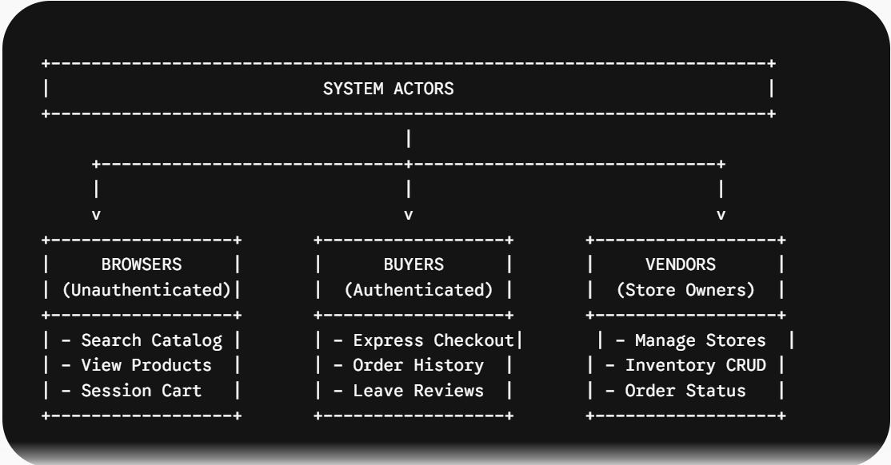

Model-View-Template Interaction Architecture
The platform relies on the Model-View-Template architectural pattern to separate database logic, request handling, and user interface rendering.
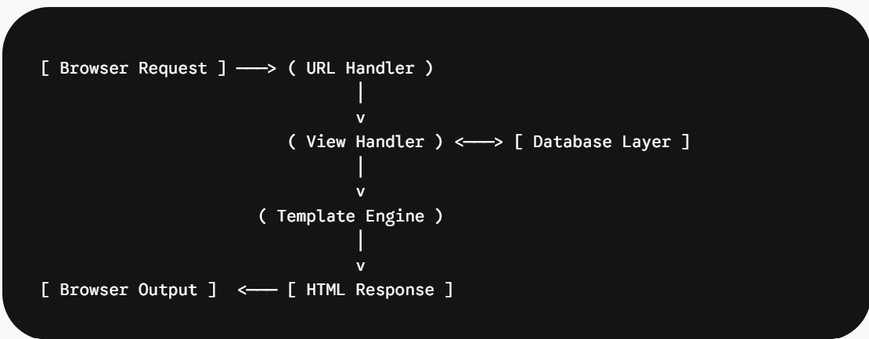
When a visitor requests a page:
- The URL Handler receives the browser's request and routes it to the correct handler based on the requested address.
- The View Handler processes the logic, fetching relevant data from the Database Layer (such as product details or store information).
- The View passes this structured data to the Template Engine, which merges the raw data with visual templates.
- The generated user interface is sent back to the browser as a complete response.

